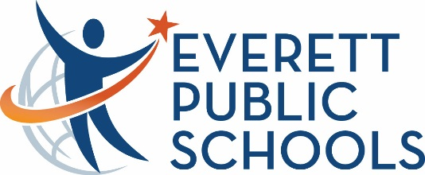***Information Only***

January 17, 2025

To: All Staff

From: Dr. Brian Beckley, Chief Information Officer

Karen Hickenbottom, Director of Learning Management Services

Regarding: **Canva for Education District Access**

Technology can be a useful tool for being productive and efficient but one of its superpowers is to allow us to create and innovate. Canva is a powerful graphic design tool that has made it easy for anyone to create professional-looking presentations, graphics, flyers, images, logos and more. Visuals are an important way to engage students, staff, and community members in your message.

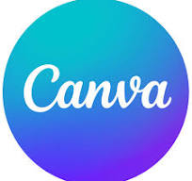

To support student and staff creativity and productivity, we are going to be making the full Canva for Education tool accessible for all staff and students over the next few weeks. **This version is the same as the Pro version but it’s free for education.** You will not need to renew any Pro licenses in the future if you switch to using the Canva for Education version.

When we make the switch, current Canva users will be able to move between their current account and their new district account by clicking on their profile and switching between them on the drop down.

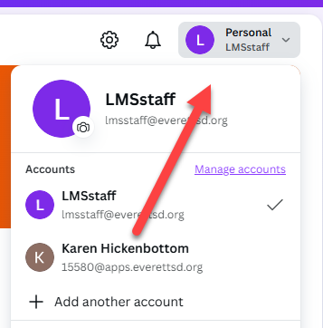

Admin, teachers, and students will be put in teams by school. Any paras or staff not assigned to schools will be in a Staff & Admin team. Being in a team allows you to share designs with others or to collaborate. We’ll also be setting up the integration with Canvas so you can assign Canva projects directly from your Canvas course.

**You will still have access to Adobe Spark and other Adobe Creativity tools** but adding Canva will provide some choice. Canva is also being integrated into tools like Parent Square, Book Creator and more so look for it to show up in more places.